TRUE BLUE CHARTERS
BLUEFIN TUNA BOOKING FORM 2024
“Silver Gannet” Skippered by Steve Porter

- ANGLER NAME.

- CONTACT PHONE NUMBER.

- HOME ADDRESS.

- EMAIL.

- DATE/S of CHARTER/S.

- DAILY RATE. £1200 7. DEPOSIT.

8. BALANCE DUE.

9. ACCOUNT DETAILS, Steven A Porter. (Personal Account)
Sort Code 40 47 81
Account Number 60256285
10. SKIPPER CONTACT DETAILS,
Tel : 07967 598669
Email : steve@truebluefishing.co.uk
Web : www.atlanticbluefin.co.uk

11. BOAT LOCATION
Mylor Yacht Harbour
Churchtown
Falmouth. TR11 5UF
NOTES

- The balance is due, preferably by BACS once the weather decision for the trip has been made. Full payment before leaving the dock is a condition of sailing.
- For weather cancelled trips, deposits will either be carried forward or returned at the anglers choice.
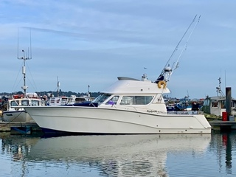
- For angler cancelled trips, the skipper will within reason attempt to fill the day and remove any liability to the angler cancelling. However, trips cancelled within two months of the trip date that are not filled may render the angler liable for 70% of the full charter fee.

